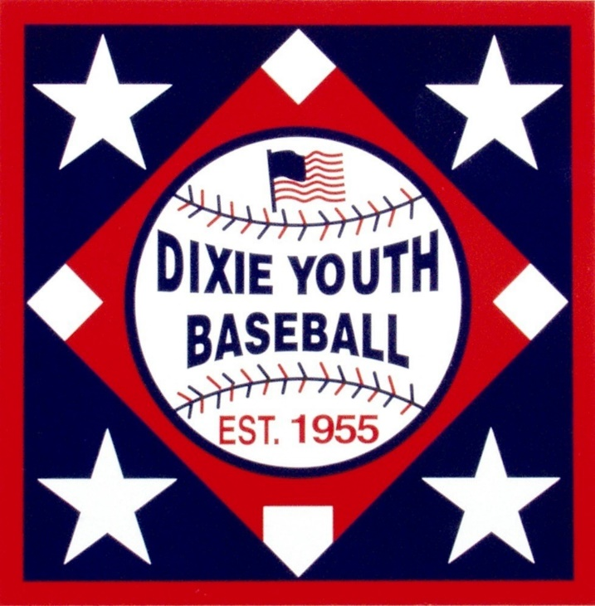

**ALABAMA**

**DIXIE YOUTH BASEBALL**

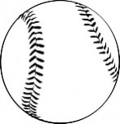

**2022 UMPIRE TRAINING MANUAL**

**UMPIRE DRESS CODE**

* *Pants* - Gray, of proper fit, clean and well pressed.
* *Belts* - Black.
* *Shirts* - MLB type pull over.

**Approved shirt colors for State Tournaments - Navy, Red, White**.

* *Shoes* - Black, lace type and in good condition and shined.

No loafers or other type of ‘slip on’ shoes.

* *Socks* - Black or Navy.
* *Ball Bag* - Black or Navy
* *Jacket* - Navy
* *Cap* - Black or Navy

**Umpires should be dressed alike** with the exception of the jacket (i.e. the plate umpire is not required to wear a jacket just because the base umpire is wearing one or vice-versa.)

**Make sure that the entire crew is wearing the same color shirt and undershirt and the same style of umpiring shirt.**

**All shirts must have the Alabama Dixie Youth Umpire patch on the left shirt pocket**.

**NO OTHER NUMBERS OR MARKINGS FROM ANY OTHER ASSOCIATION OR ORGANIZATION WILL BE ALLOWED.**

The undershirt color can vary depending on the color of the umpiring shirt being worn.

**To be eligible to umpire in any Alabama D.Y.B. tournament game a person must present proof of passing the free COACHSAFELY COURSE The certificate of completion must be dated in the current calendar year.** [**www.coachsafely.org**](http://www.coachsafely.org) **and click “ Access Training. ”**

–

***UMPIRE DO’s and DONT’S***

* The first step to being professional is to look professional, dress neatly.
* Arrive early.
* The plate umpire and at least one base umpire should have an indicator.
* Don’t talk to spectators between innings.
* Let players retrieve foul balls and bats.
* Do not allow a coach to warm up a pitcher.
* Signal infield fly with right hand and verbalize.
* If one umpire signals time out, all umpires should signal time out.
* The UIC should never make an out call with his mask in his right hand.
* Never lay your mask on the ground.
* Do not rush your call. PAUSE-READ-REACT.
* Know your signals.
* Always use the proper finger sequence for balls and strikes.
* Never touch an injured player.

***GENERAL UMPIRING MECHANICS***

* Always keep an umpire ahead of the lead runner.
* Plate and one other umpire shall carry an indicator.
* All umpires should carry their plate equipment in case of an emergency.
* Any umpire may call an Infield fly. The primary responsibility rests with the umpire nearest the fly ball. Do not make this call too quickly. Umpires should wait until the ball reaches its apex (its highest point) before making this decision.
* Do not run toward the ball. Always get an angle on the play. Never make a call while in motion.
* On foul balls – use hand signals to kill all play – then voice foul ball.
* Timing is important. **PAUSE – READ – REACT.**
* On safe or out calls avoid making a double call.
* Always use common sense in fair play.
* Call what you see – see what you call.
* Never show up your partner in front of coaches and players.

**PLATE UMPIRE**

* Follow bunted ball down foul lines.
* Will catch/no catch on all fly balls and line drives in the infield.
* With no runners on, rule fair/foul on all balls up to the first base bag and down third base line. (2 man crew)
* With no runners on, rule fair/foul on all balls up to the first bag base and up to the third base bag. (3 main crew)
* With runners on, rule fair/foul on all balls down first and third base lines when base umpire is off the line.
* Signal partner(s) in an infield fly situation or when a two out timing play is possible.
* Watch every play as if it were your call. Your partner(s) may appeal to you for help and you may also be required to decide on play situations involving rules.
* Calling “foul” halts all play. This is one call you cannot change.

**PLATE UMPIRE**

* Hustle, get out from behind the plate, and be ready to get in position to make calls.
* Foul Tip – no voice call – hand signal only. FOUL TIP IS NOT A DEAD BALL! (2.00 Def.-Foul Tip)
* Signal balls with left hand.
* Signal strikes with right hand.
* Remove mask with left hand.
* Stay down on ball calls.
* Rise up, voice, and signal strike calls.
* No voice call on swinging strikes.
* Do not run out of baseballs.
* Never voice a fair ball – point with appropriate hand.

**FIELD UMPIRES**

* Move with the pitch (one or two steps), so that when the ball is hit you are ready to move into position to cover any plays for which you are responsible.
* Always signal partner(s) in an infield fly situation and when a two out time play is possible.
* Use your head and eyes to keep from having to scurry out of the way of players.
* Exhibit proper posture at all times.
* Watch the batter, plate umpire may ask for help on check swings.
* Kill ball that hits batter immediately. Signal dead ball.
* Encourage players to hustle on and off the field between innings.
* Hustle, don’t be lazy.

**Hints for Better Umpiring**

* Relax when you work, enjoy the experience and be willing to laugh at yourself.
* From arrival at the game site to departure, look the part in dress, demeanor and enthusiasm.
* Keep your cool at all times.
* Don’t talk to spectators between innings.
* Do not rush your call. PAUSE-READ-REACT.
* Always prepare, concentrate, anticipate and hustle.

***SAFETY RULES***

* The fake bunt/hit away tactic will not be allowed. Once a batter squares to bunt, he may: pull the bat back and take the pitch or, attempt to bunt the ball. (XI (D) pg.99)
* A batter may not excessively wiggle the bat in an attempt to distract the pitcher or while attempting to bunt, pull the bat back and swing at the pitch. (XI (C) pg.99)
* Penalty: For both fake bunt and excessive wiggling =
  + First offense: Warning to the batter and the offending team’s manager.
  + Second offense in the same game: The offending team’s manager is ejected.
* Only players wearing a catcher’s mask with helmet and throat-protector will be allowed to warm pitchers up in any “sanctioned” Dixie Youth Tournament. *Exception*: Hockey style mask with extended throat-protector. (1.16)pg.30-31
* No other person, including the managers or coaches, can warm up a pitcher due to the risk of substantial facial injury from deflected balls. (1.16)pg.30-31
* Note: It is strongly recommended that local leagues adopt this policy for all practice and regular season play.

***2.00 Definition of Terms - INTERFERENCE***

* **Interference (pg. 35-36):** Offensive interference is an act by the team at bat which interferes with, obstructs, impedes, hinders or confuses any fielder attempting to make a play. If the umpire declares the batter, batter-runner, or a runner out for interference, all other runners shall return to the last base that was, in the judgment of the umpire, legally touched at the time of interference unless otherwise provided by these rules.
* **On any interference, the ball is DEAD (E pg.36).**

***2.00 Definition of Terms - OBSTRUCTION***

* **Obstruction (pg. 36):** Is the act of a fielder, who, while not in possession of the ball, or not in the act of fielding the ball, impedes the process of any runner.
* **The ball is DEAD if a play is being made on the runner or if the batter-runner is obstructed before reaching first base. (7.06 (A) pg.58)**
* **If there is no play being made on an obstructed runner, this is a DELAYED DEAD ball call. When play stops, time is called and penalties, if any, are imposed. (7.06 (B) pg.58)**

***APPEALS (6.07(b)pg. 53 - 7.10 pg. 61-62)***

* An appeal must be made while the ball is in play. If a dead ball or time has been called, the ball must be put back in play before an appeal is made.
* Any appeal must be made before the next pitch, or any play or attempted play.
* An appeal shall be clearly intended as an appeal, either by verbal request by the player or by an act that unmistakably indicates an appeal to the umpire.
* If an appeal is to be made on a base runner at the end of an inning, it must be made before the defensive team leaves the playing field (fair territory).

***EQUIPMENT***

* The bat barrel shall not exceed 2 5/8” in diameter. 1.10 (pg. 28)
* The bat shall not exceed 33” in length. 1.10 (pg. 28)
* All non-wood and multi piece wood bats must be marked with the USA BASEBALL stamp. 1.10 (pg. 28)
* Solid wood bats do not have to have the USA BASEBALL stamp but shall not exceed 2 5/8” in diameter nor 33” in length. 1.10 (pg. 28)
* 2 5/8” bats that are -3 BBCOR certified are legal for regular season and tournament play. 1.10 (pg. 28)
* All bats stamped BPF1.15 are not legal for play in any division. 1.10 (pg. 28)
* Any bat stamped for T-Ball cannot be used in games played in the AA, AAA, Majors or “O”Zone divisions. (1.10(c)pg. 28)
* All 2 ¾” barrel bats are prohibited in all divisions of Dixie Youth Baseball. 1.10 (pg. 28)
* A batter who uses an illegal bat shall be called out and all runners shall return to the bases occupied by them at the time such batter took his position in the batter’s box if protested by the opposing team manager prior to the first pitch to the next batter. A batter uses a bat when he takes the first pitch from a pitcher during any time at bat. The bat becomes illegal when the batter receives the first pitch during his turn at bat. He does not have to hit the ball. Batter will be called out and any runners must return to the base they occupied prior to the first pitch to the batter (1.10(d)pg.28)
* The batter’s helmet shall be worn by any offensive player while on the playing field, such as a bat boy, on-deck batter, batter, base runner or player base coach. (1.15(c) pg.29)
* A Chin strap on the batter’s helmet is optional. (1.15(a)pg.29)
* Any player warming up a pitcher on the mound, in a bullpen or elsewhere shall wear a catcher’s mask with helmet and throat protector, NOT A BATTER’S HELMET. (1.16(g)pg.31)
* Players or other personnel on the field, including managers, coaches, umpires, etc., shall not wear shoes with cleats (molded or screw-on) that contain any metal materials. (1.11(C) pg.29)
* Defensive players may wear sunglasses. (1.11(D)(1)pg.29)
* Players on the field or in the dugout area shall not wear jewelry of any kind, for safety reasons. This includes bracelets, necklaces and piercings of any kind. EXCEPTION: Players may wear breakaway sports necklaces. Medical or religious tags or medallions may be worn and secured by tape (1.11(D)(2)pg.29)
* The catcher must wear a catcher’s mitt (not a first-baseman’s mitt or fielder’s glove). (1.16 pg.30)
* The pitcher’s glove may be of a contrasting color, including all stitching, lacing and webbing. The pitcher’s glove may not be white or gray.(1.14(A) pg.29)
* Catcher’s helmets are required to bear the NOCSAE seal (1.16(b) pg. 30)

***Alabama uses the Continuous Batting Order, all players bat.***

* If a player listed in any batting position in a continuous batting lineup leaves the game because of an injury, illness or disqualification, this position in the batting lineup will be skipped for the remainder of the game without penalty. No player will be called “out” who is skipped.
* There are two fundamentals to keep in mind: When a player bats out of turn, the proper batter is the player called out. If an improper batter bats and reaches base or is out and no appeal is made before a pitch to the next batter, or before any play or attempted play, that improper batter is considered to have batted in proper turn and establishes the order that is to follow. (6.07 pg. 53)
* Two runners may not occupy a base, but if, while the ball is alive, two runners are touching the base, the following runner shall be out when tagged. (7.03 pg. 56)
* A runner is out if the runner runs more than three feet away from a direct line between bases to **avoid being tagged**, unless such action is to avoid interference with a fielder fielding a batted ball. (7.08(a)(1) pg.58)
* A runner is out if the runner does not slide or attempt to get around a fielder who has the ball and is **waiting** to make the tag; **NOTE**: The ball is dead and other base runners take bases they had reached, in the umpire’s judgment, when the violation occurred. (7.08(m) pg. 60)
* AAA & Majors - When a pitcher is in contact with the pitcher’s plate with the ball in his possession, and the catcher is in the catcher’s box in position to receive the pitch, all runners shall be in contact with their bases and shall not leave their bases until the pitch has reached the plate. (7.13(a) pg. 62)
* AAA & Majors - If a runner leaves the base before the pitch reaches the plate, the defensive team shall have the privilege of nullifying any portion of the play that occurred after the violation. (Exceptions – ground rule double, home run over the fence, batter is hit by pitch). (7.13(b) pg. 62)
* With the exception of the pitcher in Majors,“O”Zone and AAA Division play, any player may enter the game on defense in any defensive position as many times as deemed necessary by the team manager. (3.03 (e)(1) pg. 42)
* Players may enter the game on defense only at the beginning of each team’s defensive inning unless the defensive player enters the game to replace an injured, ill or ejected player or enters the game during a pitching change. (3.03 (e)(2) pg. 42)
* **15 RUN RULE** - A game shall be considered a regulation game when a team is ahead by fifteen (15) runs after both teams have batted three times or more and all players on both teams have batted at least once, or in the case of the home team when it is leading, at least two times. (4.10(A)9 pg. 46)
* **10 RUN RULE** - A game shall be considered a regulation game when a team is ahead by ten (10) runs after both teams have batted four times, or in the case of the home team when it is leading, three times. (4.10(A)5 pg. 45)
* Noisemakers may be allowed by the tournament director; however, spectators may not use noisemakers in an attempt to distract the pitcher’s delivery of the pitch to the batter. Any such action will be deemed unsportsmanlike conduct and will not be permitted by the umpire. (XI. (b) pg.99)

***AA Tournament Rules (pg.103-107) –***

* The infield fly rule is not applied.
* No bunting or base stealing is allowed.
* The pitching coach may coach or position the batter only. He/she cannot coach runners.  A warning will be given for first offense and he/she will be removed from the mound on the second offense.
* A regulation game shall be (6) innings for tournament play unless the 15-run rule applies (fifteen runs after three (3) innings) or the 10-run rule applies (ten runs after four (4) innings).
* The 15-run rule will apply after three innings only if all players have completed one time at bat.
* An umpire will call time out when the play comes to a natural end and base runners are making no attempt to advance.
* If a batted ball hits a coach pitcher, the ball is dead and will be declared “no pitch”.
* A batting helmet with a face mask is required for the player pitcher.